Web Design and Development

4COSC011W

Report

Author: ***Tomasz Dawid Wasowski***

Student ID: ***w1684891***

Group Number: ***4CSE_10_g1***

Student Role: ***Student 3***

Link(s) to WebSite

URL:

* **Quiz :** <https://w1684891.users.ecs.westminster.ac.uk/coursework/dawid/Quiz/quizPage.html>
* **Student Profiles:** <https://w1684891.users.ecs.westminster.ac.uk/coursework/dawid/Student%20Profiles/studentProfilesPage.html>
* **Additional Page:** <https://w1684891.users.ecs.westminster.ac.uk/coursework/dawid/Additional%20Page/additionalPage.html>
* **Editor’s Page:** <https://w1684891.users.ecs.westminster.ac.uk/coursework/dawid/Editor%20Page/editorPage.html>

1. Introduction 3

2. Technical Discussion 3

2.1 (Student 3) Quiz 3

2.1.1 Preparation 3

2.1.2 Implementation 3

2.2 (Student 3) Student Profiles 7

2.2.1 Preparation 7

2.2.2 Implementation 7

3. Discussion of UI and application of UX principles 8

3.1 Information architecture 8

a. Design 8

b. Code to achieve good Information architecture 10

3.2 Colour balance/composition/graphics/consistency 10

a. Design 10

b. Code to achieve good colour balance & ensure consistency 11

c. Colour contrast test results 11

3.3 Typography / consistency 12

a. Design 12

b. Code to achieve good typography / consistency 12

3.4 Gestalt principles grouping 12

3.5 Accessibility (graphics/forms) 14

a. Graphical elements - Design/Code 14

b. Form completion - Design/Code 15

3.6 Error prevention and recovery 15

a. Design 15

b. Code to address error prevention and recovery 15

4 Janet 16

5 Conclusions 16

References 16

Appendices 17

Appendix A: Code 17

Appendix B: Screenshots 18

Appendix C: Individual Statement 22

# Introduction

Team Members:

* Daniel Gniadecki (Student 1)
* Avinesh G Sudhakaran (Student 2)
* Tomasz Dawid Wasowski (Student 3)
* Rikeith Trivedi (Student 4)

Our chosen topic is **Entertainment**.

# Technical Discussion

## 2.1 (Student 3) Quiz

### 2.1.1 Preparation

I’ve began working on this task by highlighting through the specification and mark scheme, listing all requirements for this task. Once I knew what was required, I’ve scoured the internet for examples of trivia quizzes, making notes of how different websites applied the features I was tasked with implementing.

I paid attention to how quizzes were structured, styled and formatted. I’ve identified a few common styles and ended up settling on a ‘Who wants to be a millionaire’ format of separately displayed questions with 4 answers. Another commonality I’ve found that I decided to include, was the use of supporting images to clarify the short, trivia-styled questions of the quiz.

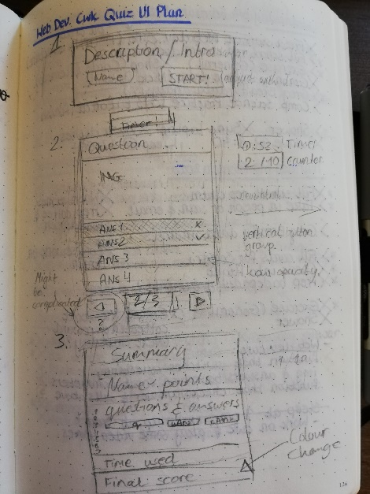

Figure 1 - Quiz UI Sketch.

With the above in mind, I planned to split the quiz into 3 states: introduction, questions and summary. These would later become <div> blocks which I could switch between to ensure a smooth transition for the user.

I decided to sketch out the formatting I wanted to achieve, while considering the best methods for implementing it with the tools I had available.

### 2.1.2 Implementation

Before I get into detail on my implementation methods, I would just like to preface by mentioning that my implementation process was an iterative one, and different aspects of the task were constantly returned to and adjusted as necessary. That said, I will try and structure this section into HTML, CSS and JavaScript, as that is how I structured the files of my pages. (CSS and JS written externally and linked to the HTML).

I began implementing the quiz by creating a prototype, starting with a general structure of the page within HTML. I’ve created the 3 <div> blocks, which would correlate to the 3 states of the quiz and filled them with appropriate elements and id/class attributes. These included elements such as the start <button> for the intro div, or the question <h1> and answer buttons for the question div.

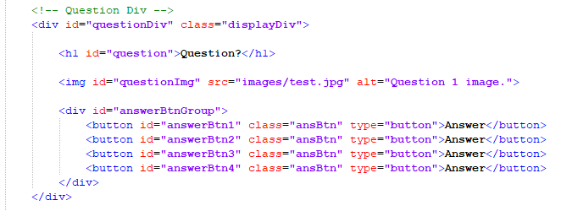

Figure 2 - <div> structure of the 2nd quiz state.

Once I’ve had this skeleton set, I began applying very basic CSS styling to get my quiz resembling the UI sketch above. This styling included the adjustment of width, float, padding, margins, text-align and a variety of others to achieve a format that allowed me to apply basic functionality. The style sheet was very messy at first, but I began noticing patterns of elements that needed to share the same styling. This process allowed me to assign appropriate classes to elements and create a very defined, standardized style sheet for the final quiz.

I kept my focus at the idea of constant refinement, efficiency and reusability, trying to achieve the most amount of styling with as little CSS code as possible. I’ve also tried to style the quiz to allow for adaptability with different screen resolutions, trying to keep the width attribute as a percentage to allow for expansion, while keeping the height attribute as a px value to keep the content definition. I ended up having to restrict the width to a minimum of 1114px, to preserve the quiz formatting when the user zoomed in.

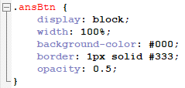

Figure 3 - Answer button class styling.

With basic CSS completed, I moved on to implementing functionality using JavaScript. The quiz was intended to have 10 questions, but I only built the HTML to contain 3 states. This means that the second ‘question’ state would have to be repeated ten times, one for each question.

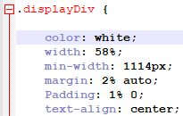

Figure 4 - Common styling for the 3 quiz states.

Initially, I worked on making this process work for just one question. This is where I implemented functionality to all the answer & next buttons, adding event handlers and creating functions.

When the user clicked on an answer button, a function would trigger which would ‘disable’ all the answer buttons and enable the ‘next’ button, meaning that the user would not be able to click more than their original answer. This was achieved by removing the event handlers and changing the styling on the buttons to appropriately alter their appearance by ‘graying’ them out.

The answer would then be checked and the button would highlight green if the answer was correct (also adding 2 points to the user’s score) or highlight red, with the correct answer being highlighter green (taking 1 point away from the user’s score). The user’s answer and status (correct/incorrect) would also be appended to the innerHTML of the summary state.

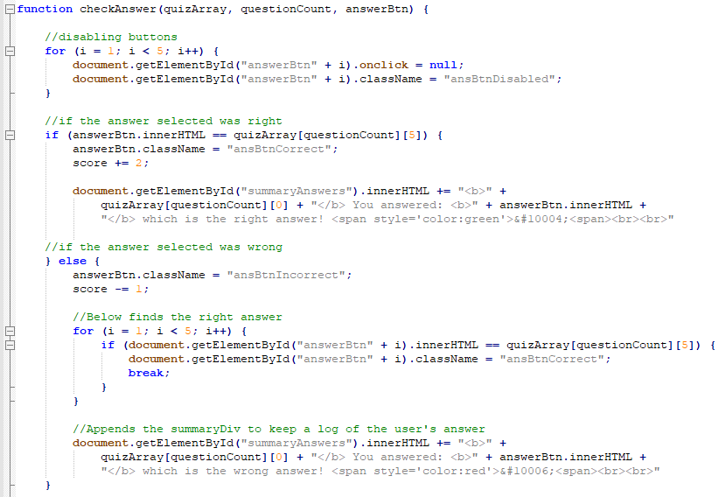

Figure 5 - Function that checks the user's answer.

Once the user clicked next, a function was triggered which changed the question, supporting image and answers, and then reapplied event handlers and ‘re-enabled’ the answer buttons, while greying out and disabling the ‘next’ button.

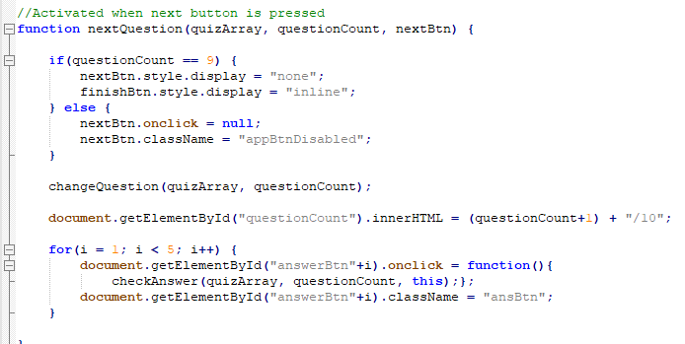

Figure 6 - Function called when the next button is clicked; calls question change and re-applies event handlers.

Once I managed to get this process working for one answer, I refined the functions to make them reusable and scalable. I also created a 2d array that held the 10 questions, with the question as the first element, answers as element 2-4, the correct answer at element 5, and the supporting image link as element 6. I then passed the array, as well as a pointer to the current question as parameters, through the functions called by onclick events.

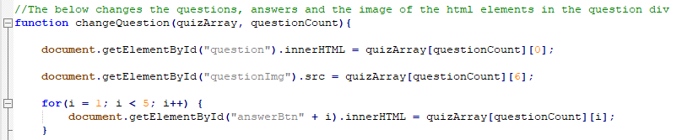

Figure 7 - Function which changes the question and answer HTML objects.

Every time the user hit the next button the pointer was incremented to point to the next question. The entirety of this process was completed with the use of local parameters, smoothly passing them between the functions until the pointer was the same value as the length of the array, at which point the ‘next’ button would turn into a ‘finish’ button and take the user to the summary page.

The summary page would already have a log of the user’s correct/incorrect answers and would just print the final score below. In addition, a function was created to calculate new RGB values for the page background attribute using the score value. This meant that every score would have a varying shade of appropriate colour.

Lastly, I focused on implementing the ‘timer’ mechanic. I did this by setting an interval on a function called tick to run every 1000 milliseconds, which would update the html labels for the timer, by decrementing a second every iteration. The most complex part of this code was ensuring that the labels change correctly when the timer passes the ‘x:00’ mark.

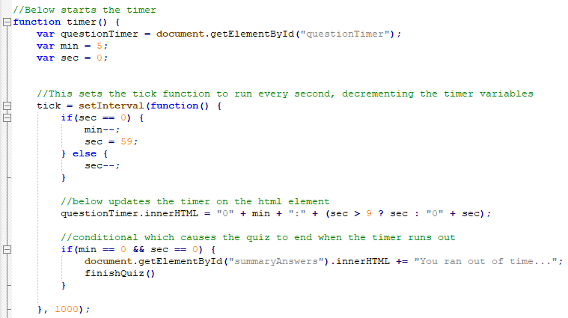

Figure 8 - The timer function and interval method.

I then created another function which would use some simple addition and string manipulation to calculate the time taken by the user and display it on the final screen. There was also a conditional to check whether the user run out of time, which would cause the quiz to end.

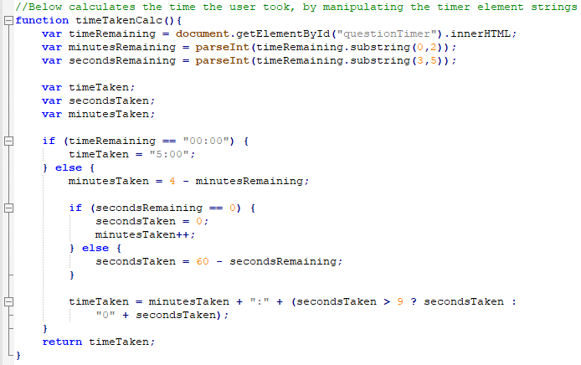

Figure 9 - Function which calculates the timer the user has taken.

## 2.2 (Student 3) Student Profiles

### 2.2.1 Preparation

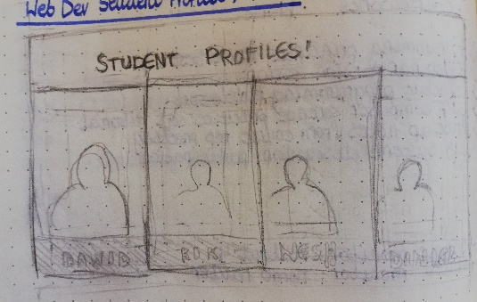

Figure 10 - Sketch of student profiles page.

I began work on the student profiles by sketching out the final page, to give me a starting point on which I would base my HTML and CSS. I’ve done a little research on websites which would introduce team members, and tried to go for a similar, side by side aesthetic.

### 2.2.2 Implementation

I’ve implemented the profiles as a set of 4 <div> blocks, with a few common elements, such as an image and another ‘footer’ div which would hold the student name, and an ‘info’ div which would hold further information about the student.

In my JS file, I have attached onMouseOver and onMouseOut event handlers to each student profile div, which changed the footer display attribute to none, and made an overlay image with the student’s information visible. This effect was reverted as the user moved the mouse away from the profile.

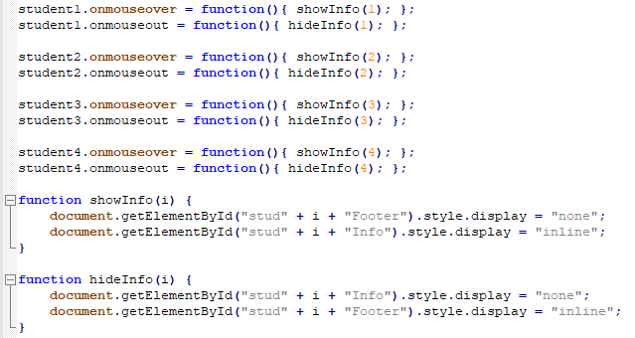

Figure 11 - Attaching event handlers and their respective functions.

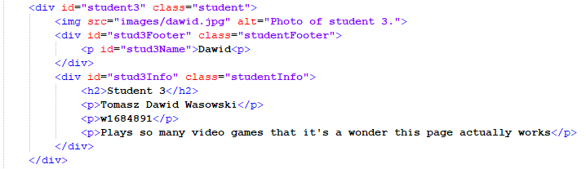

Figure 12 - One of the 4 student profile div blocks.

# Discussion of UI and application of UX principles

## 3.1 Information architecture

### a. Design

We decided to structure the website by splitting the folders into each student, which would then split the folders into each task. This allowed our files to use relative links to connect to each other, making the navigation menu reusable while allowing minor adjustments to be made without the need to re-verify the links each time.

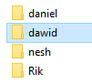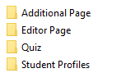

Figure 13 - Website folder structure: Student Name -> Individual Task

I wasn’t personally in charge of creating the navigation menu (that was one of the tasks of student 2), but we have decided to use a very linear structure of access. Since our website only consists of a handful of pages, we have given each one an individual link on the nav menu.

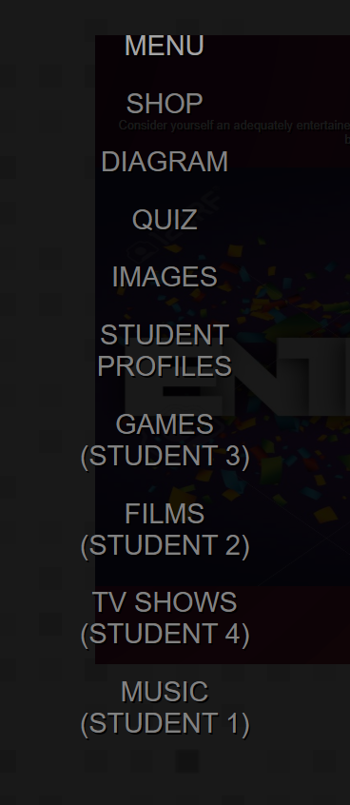

Figure 14 - Each page has its individual link in the menu.

As such, we hope that there is no need for a breadcrumb trail, since the navigation tree is so shallow that the user ought to be able to clearly identify their location on the website without one, as it only ever takes one step to jump from any part of the website to any other.

For a website of higher complexity or larger size, I personally would create a more of a folder-like, tree structure which would include a breadcrumb trail in the header for easy identification and access to previously visited pages.

Our navigation system was created by student 2, which then asked us to copy and paste the code onto our individual pages to maintain consistency. The navigation menu was implemented as a small thumbnail in the top left corner which, upon clicking, expanded to provide links to the rest of the website.

The navigation menu uses two functions for when the button/background are clicked, which open/hide the navigation menu respectively. I think it would have been a good idea to implement a menu that would be permanently visible, as some of our tasks required the change of background colours, some of which made the thumbnail difficult to distinguish from the background.

When it came to structure my pages to direct the user to the content, I focused on a few different aspects. One, was to create a central div which had a different background colour than the body and held all the primary content of the page. With a subtle, white body background, this daring, central div attracted the user’s eyes to the contents held within.

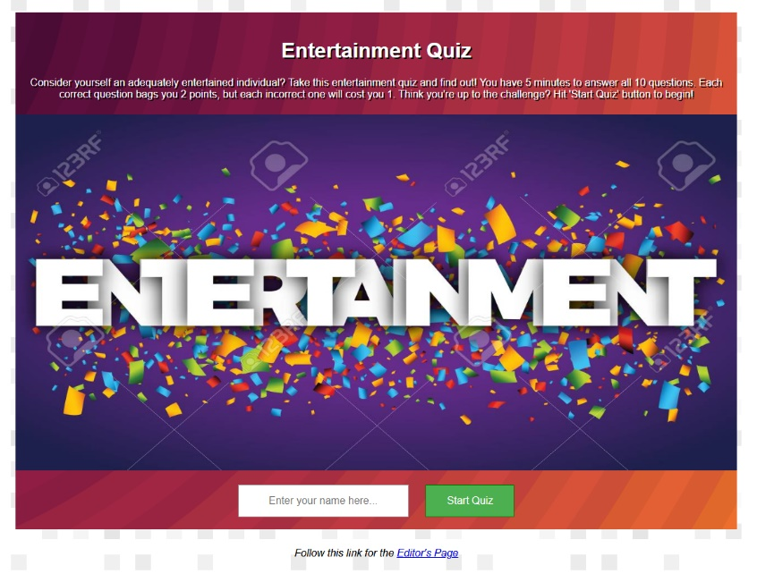

Figure 15 - Quiz intro page.

Another method, especially used with my quiz, was the use of large images within the central div, which further brought the focus point towards the content around the image.

I also used large, green buttons to propagate the user towards clear progression on the page, as only a small quantity of content was available to the user at once. This meant that the user could focus on the content, and properly digest it, before being exposed to more (i.e. another question – as opposed to a questionnaire style quiz where multiple questions are visible at once.)

### b. Code to achieve good Information architecture

We haven’t created a template for our website, thought we were asked by student 2 to copy and paste the navigation menu onto our individual pages to maintain consistency. I have taken this a step further and created a set of relative links which allowed us all to use the same code, without having to fiddle with re-linking every single page to every other.

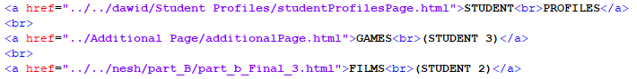

Figure 16 - Relative links in our navigation menu.

Our student 2 has also allowed us to link directly to his external CSS sheet, which styled the menu in accordance to his design.



Figure 17 - Link to external CSS which style's the menu.

That said, a clear-cut template for our website would have certainly made merging the pages together significantly easier.

## 3.2 Colour balance/composition/graphics/consistency

### a. Design

The colour combination on my pages was done for a mixture of purposes. Primarily, I’ve used SVG background templates that I found online, which were slightly more intricate than block colours and maintained sharp scalability (Zooming in without resolution loss).

The background colour used for the body of the page is a simple, clean white with some grey textured squares. This background is simple enough to not attract any attention away from the main content of the page, while also making it easy to adjust its background colour for one of my tasks.

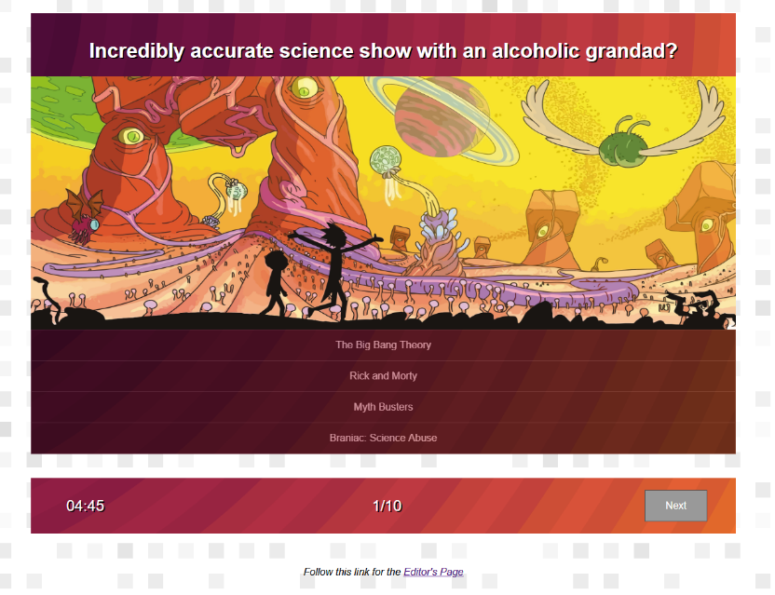

Figure 18 - The first question displayed upon starting the quiz.

On top of that, the central div has another SVG background which I found online, which transitions from a dark magenta to a bright orange. I thought that this colour works very well for our topic of ‘entertainment’, as magenta signifies creativity and fantasy while orange signifies joy and cheerfulness.

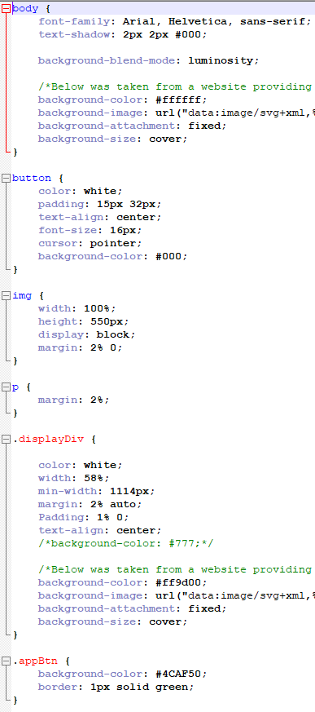

Figure 19 - A portion of the CSS written for my quiz.

In addition to this, as mentioned before, I’ve focused on using a significant amount of large, relevant images. Since the quiz is related to entertainment, much of which is focused around visual aspects (such as video games, TV shows and movies), I thought that providing these large images will help the quiz comply with the brand.

I used white text with a black text-shadow to ensure clear visibility on the colourful background. I also focused on using large buttons with plenty of padding to maintain a good visual balance with the large images. The layout of the central div is also very progressive, with the question at the top, followed by the supporting image and all the answers just below. Once an answer was selected, the button to continue was further below that.

### b. Code to achieve good colour balance & ensure consistency

I wrote a significant amount of CSS to style the quiz to maintain the consistency of composition in the central div, especially throughout all the functionality.

My HTML was structured using <div> blocks, and I focused most of the styling based around those, to ensure the consistency across the different quiz states.

### c. Colour contrast test results

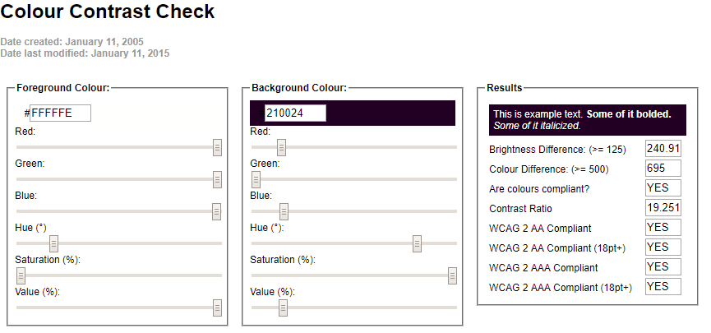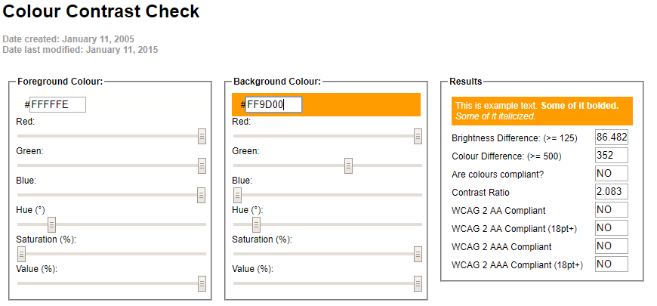

Figure 20 - Contrast test results.

Since the SVG background that I’ve used has a transition between2 different colours, I decided to perform the test on both of them.

Though the brightest colour in the background has a rather poor contrast ratio, the majority of the transition is significantly better. In addition, I added a text-shadow attribute to all my white text to help it stand out and be more readable.

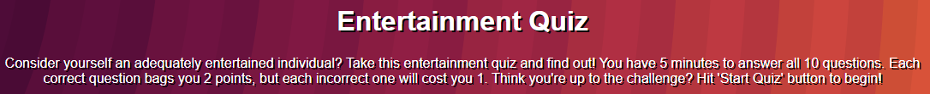

Figure 21 - Example of text-shadow improving text clarity.

## Typography / consistency

### a. Design

Since the quiz was tasked to be time limited, I wanted to choose a font that is clear, visible, with tall letters to improve readability. I ended up going for the Arial, Helvetica, sans-serif font-family for this, which is a good standard for web pages. I applied this font-family, as well as a text shadow, to the entire body. Since most of the text would be viewed on the transitioning background, I thought this would be a good standard.

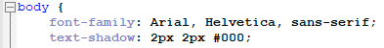

Figure 22 - General text styling for the page.

For cases which needed alterations, such as the text in buttons or the input field, I simply removed the text-shadow to make the object look more interactive, while keeping the clear font and size. Another small change was to add a 2% margin to the <p> tag styling to ensure that the spacing between text fit the styling of the rest of the objects.

I’ve used <i> for the footer and <b> to signify the user’s answers shown on the summary page. I also used a <span> tag to change the colour styling of the ticks and crosses following the user’s answer.

### b. Code to achieve good typography / consistency

To ensure consistency, I simply structured my CSS to apply the most common style to the overall element (i.e. body) and made smaller changes as necessary to individual classes/ids.

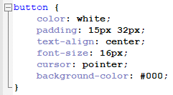

Figure 23 - Text adjustments for buttons.

These changes included things like removing the text-shadow, changing text colour or adjusting text-align to centre.

## Gestalt principles grouping

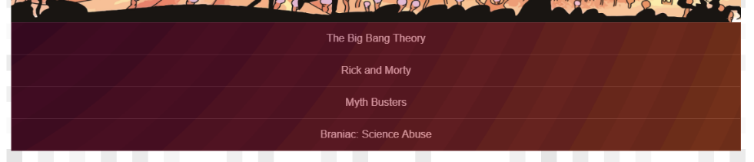In my quiz I used most of the gestalt principles with the answer buttons, which is the main part of the quiz that the user will interact with.

Figure 24 - Quiz answer buttons.

In this example, I’ve applied **proximity** of the buttons which makes them appear to form an interactive group. The user can easily tell that these all perform the same function and will answer the same question.

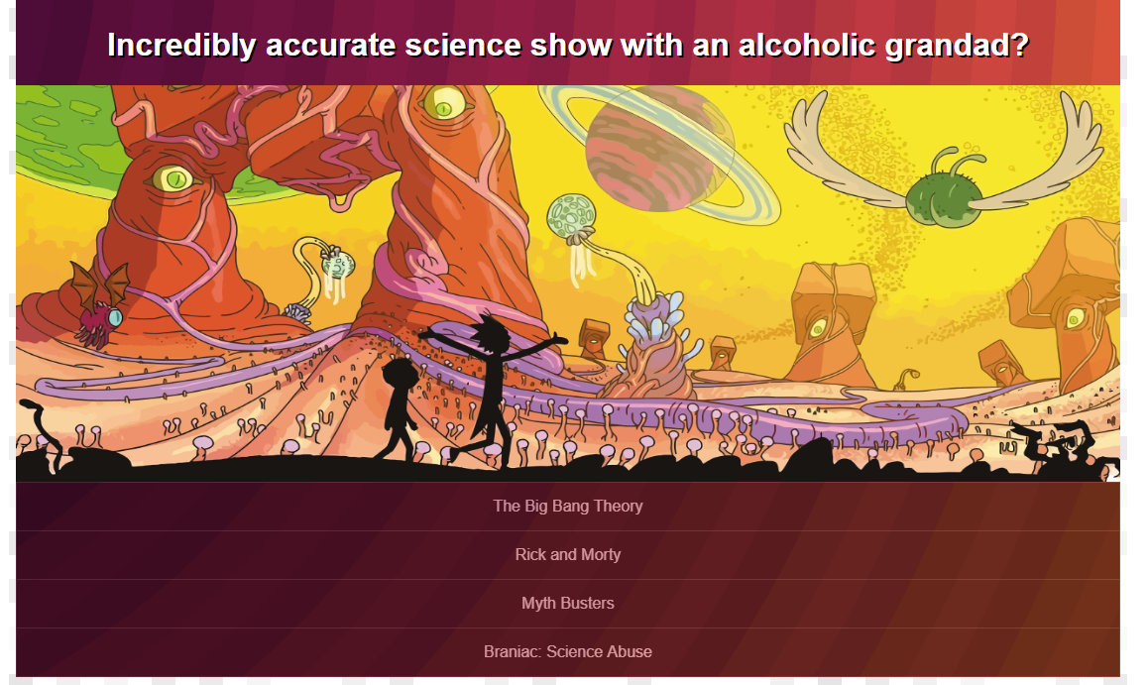

Figure 25 - An example of closure within the quiz.

I’ve also applied **closure** in the same example of these buttons, by drawing a line between each button to signify that they are separate objects. This effect of closure is also displayed with the use of the supporting image. By giving the image 100% width of the containing div block, it causes a closure effect, separating the question and the answers.

Another creative use of **closure** was by using different heights of student profile images on the student profiles page. This helps make the individual students more explicit.

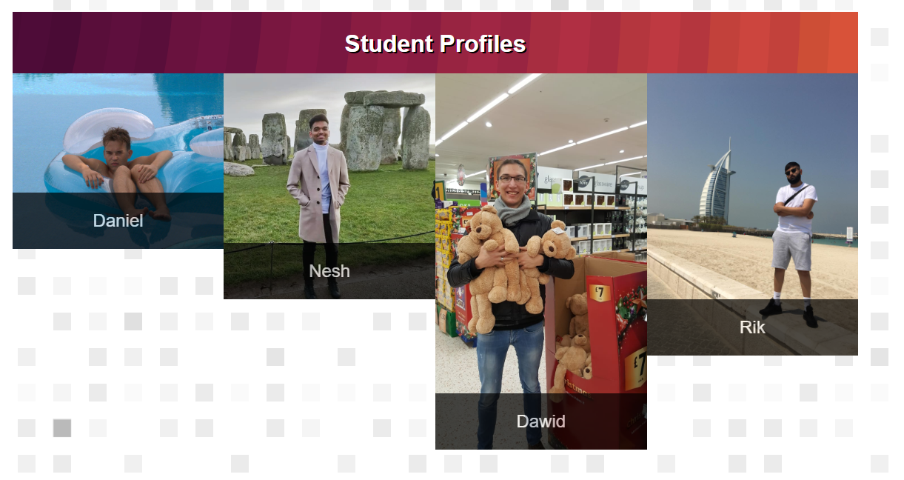

Figure 26 - An example of closure, continuation and similarity on the student profiles page.

An example of **continuation** can be seen on the student profiles page, with the box containing the student’s name seemingly continuing beyond it’s ending point. This makes the student profile image and name seem to be enclosed by an individual box.

The principle of **similarity** is applied to many aspects of both the quiz and student profiles.

The quiz uses similarity between the different questions, which are all very similar to each other making it obvious for the user to tell that after clicking next they have moved on to another question, rather than a different part of the page.

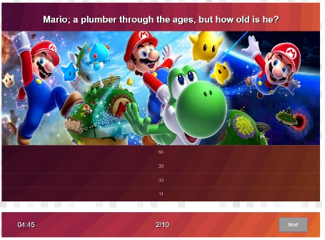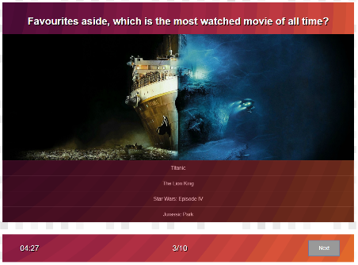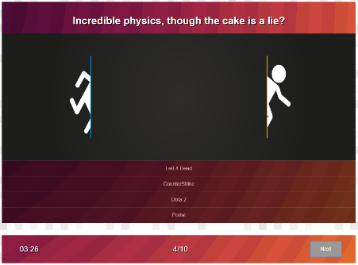

Figure 27 - Example of similarity between different questions.

Another example of **similarity** in the quiz are the buttons start, next and finish buttons, which are all styled the same to convey that they all follow the same functionality of switching to a different quiz state.

There is also **similarity** used in the student profiles between the combinations of student images and names. This shows the user that these 4 student profiles share the same functionality.

## 3.5 Accessibility (graphics/forms)

### a. Graphical elements - Design/Code

I’ve used several tags such as <i> and <b> to contain descriptive or important bits of information, such as <i> around the footer note and <b> around the question and user answers on the summary page.



Figure 28 - Example of <b> being used to signify importance.

Another precaution I’ve taken is to ensure that every image has an ‘alt’ attribute with alternate text which appears in the case that the image might not load.



Figure 29 - Example of 'alt' attribute.

I’ve also used the ‘defer’ attribute when linking my script, to ensure that all the HTML objects are loaded before the scrip loads event handlers. Ensuring that everything loads in the correct order and will function independent of PC/connection speed.



Figure 30 - Example of 'defer' attribute.

### b. Form completion - Design/Code

The only form element that I have, is an input field for the user’s name, and that one isn’t even within an actual form. I haven’t used the ‘required’ attribute to force the user to enter their name, because I thought it would be more accessible to allow the user to take the quiz anonymously.

As such, I have accounted for this in my JS code, adding a conditional clause to adapt for the user’s name (or lack thereof) when printing the final score.



Figure 31 - JS code which accounts for whether the user input their name or not.

## 3.6 Error prevention and recovery

### a. Design

I have explained the only case of form completing and error prevention from user input in the section above. To add to this, I have designed the quiz in such a way that is very intuitive in terms of progression. For example, I have written different CSS classes for different states of buttons, one class for if the button is active, and another if the button is inactive. These make it clear what the user is supposed to interact with at any given time.

It could also be argued that the images used in my quiz are supportive of the trivia-styled, somewhat vague questions, as they relate or give a hint towards the direct answer.

### b. Code to address error prevention and recovery

Once again, an example of this code was given in figure 31. In general, I have written the JS code to account for every possible user input, using conditional statements to account for every output. The majority of user interaction is done by clicking buttons, which in itself prevents many errors from, for example, user-input answers where the input data type has to often be accounted for.

Every single button has an active and an inactive state, at which points event handlers are either attached or stripped from these buttons. As such, the user cannot press a button when they are not intended to (Such as proceeding to the next question without answering the previous one).

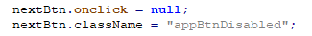

Figure 32 - Example of button switching states after it is pressed.

# Janet

My pages comply with the Janet regulations as they are not obscene or offensive in any way. They do not contain material of a threatening nature and there is no intention within them to harass or frighten.

The pages do not contain any unsolicited commercials or advertisements and, due to the academic nature of this project, no material on the page infringes copyright laws. All images are used for a creative/academic purpose and no profit is being made from this site.

There is no deliberately disruptive purpose to the website, or any infringement of the user’s security via hacking or any other means.

# Conclusions

I am rather happy with the work I have done individually for this coursework. I am happy with how my quiz and the student profiles turned out. I found the greatest technical challenge in creating a scalable JavaScript system for the quiz questions, using a 2D array and attempting to use all event handlers to correctly pass local parameters.

I think that I struggled working as part of a group in this assignment, partially because of the individual nature of the task I was assigned. I think that, in the future, I will put more effort into planning out the development and merging of our work as opposed to working on my individual task before considering how it would fit into the website.

I think that creating a template to ensure that everyone’s work matches would have been significant at the beginning of our work, as most of our issues have been in compatibility between our pages.

I would have liked to make my quiz blend into the theme of the website a little more, as opposed to be a somewhat stand alone, individual package. I would also have liked to spend a little more time working on my additional page to implement my own styling and navigation menu.

# References

* SVG Backgrounds were taken from: <https://www.svgbackgrounds.com/>
* A lot of CSS styling was fixed with the help from: <https://www.w3schools.com/css/>
* Additional page was based on: <https://www.wired.com/story/most-anticipated-videogames-2020/>
* The navigation menu for my pages was created by Nesh G Sudhakaran (Student 2).
* Images for the quiz were taken from google image search.

# Appendices

## Appendix A: Code

Filename: **quizPage.html**

Code: <https://pastecode.xyz/view/7b2ec154>

Filename: **quizScript.js**

Code: <https://pastecode.xyz/view/dc320c38>

Filename: **quizStyle.css**

Code: <https://pastecode.xyz/view/cc093264>

Filename: **studentProfilesPage.html**

Code: <https://pastecode.xyz/view/0d1de8a1>

Filename: **studentProfilesScript.js**

Code: <https://pastecode.xyz/view/5c3eea70>

Filename: **studentProfilesStyle.css**

Code: <https://pastecode.xyz/view/115cf597>

Filename: **additionalPage.html**

Code: <https://pastecode.xyz/view/61ae6168>

Filename: **additionalScript.js**

Code: <https://pastecode.xyz/view/45a497be>

Filename: **additionalStyle.css**

Code: <https://pastecode.xyz/view/5281b9b6>

Filename: **editorPage.html**

Code: <https://pastecode.xyz/view/db90cc40>

Filename: **editorStyle.css**

Code: <https://pastecode.xyz/view/66a17cf9>

## Appendix B: Screenshots

Filename: **quizPage.html**

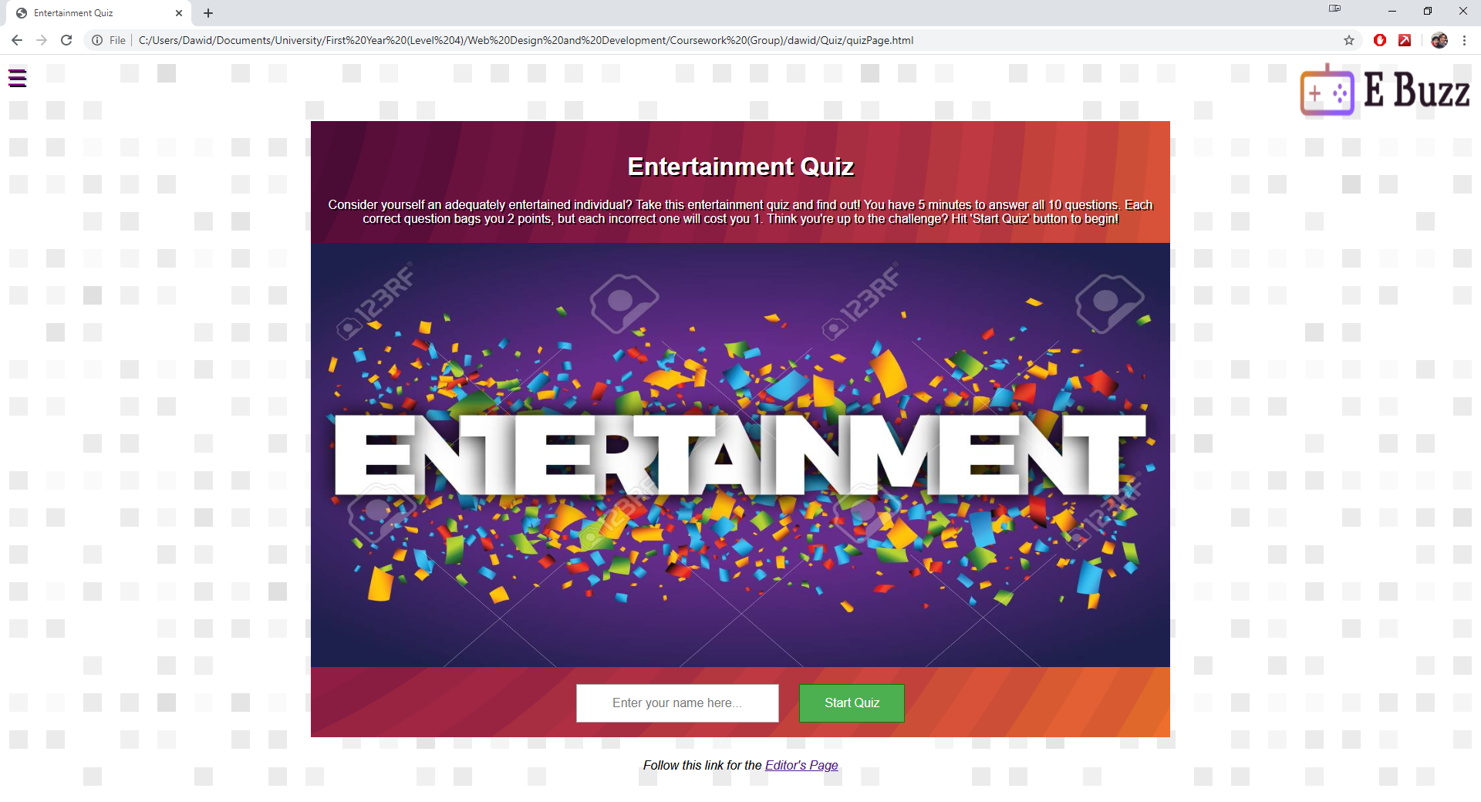

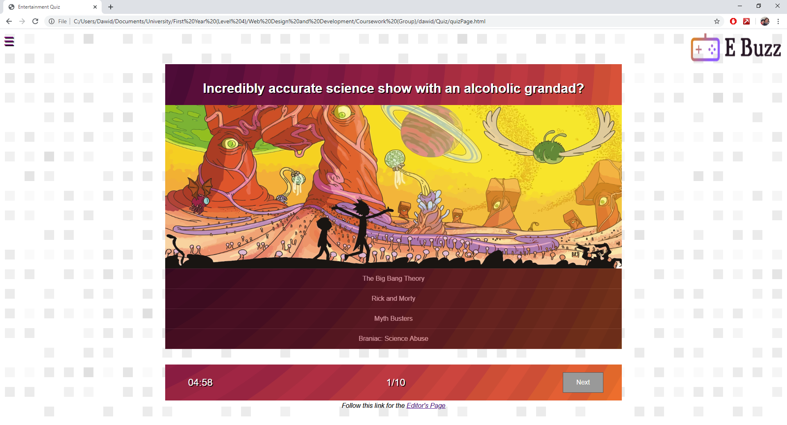

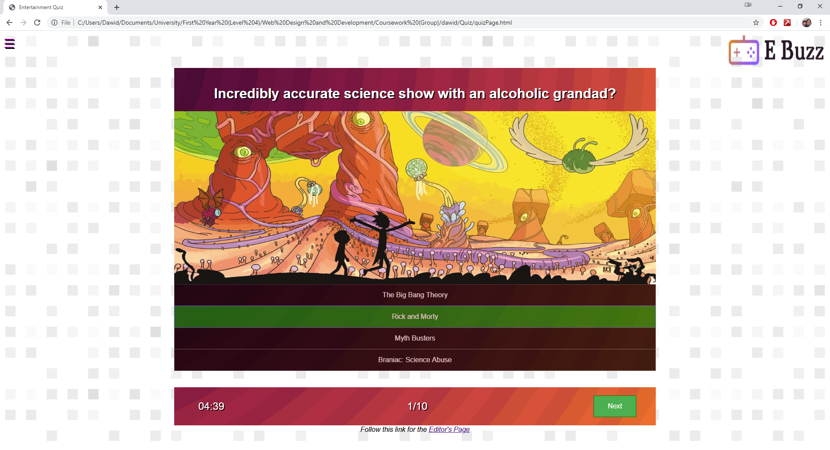

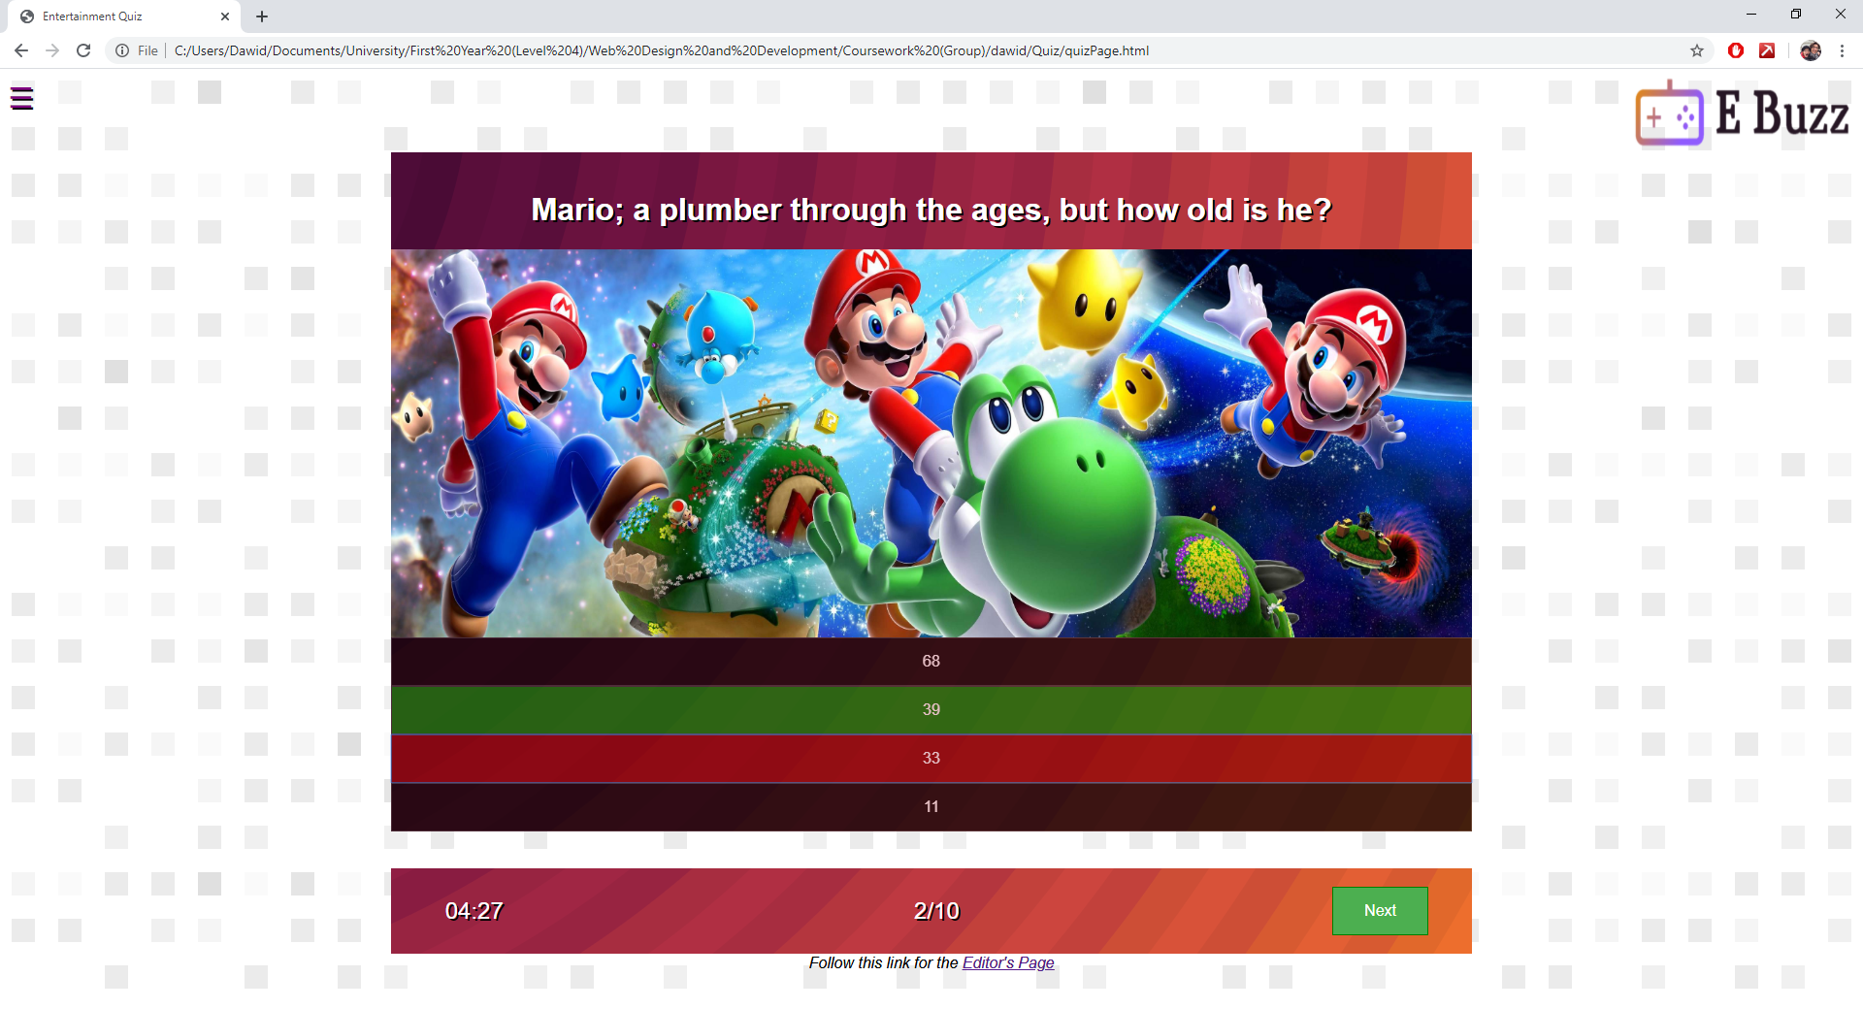

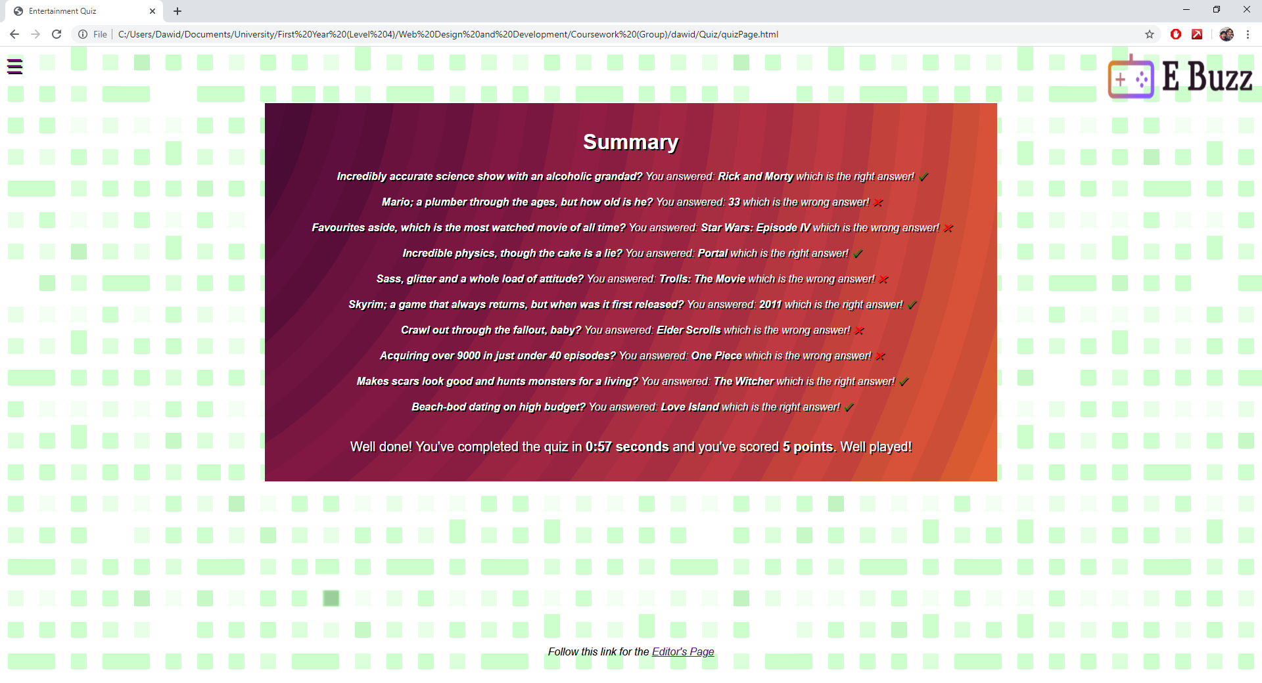

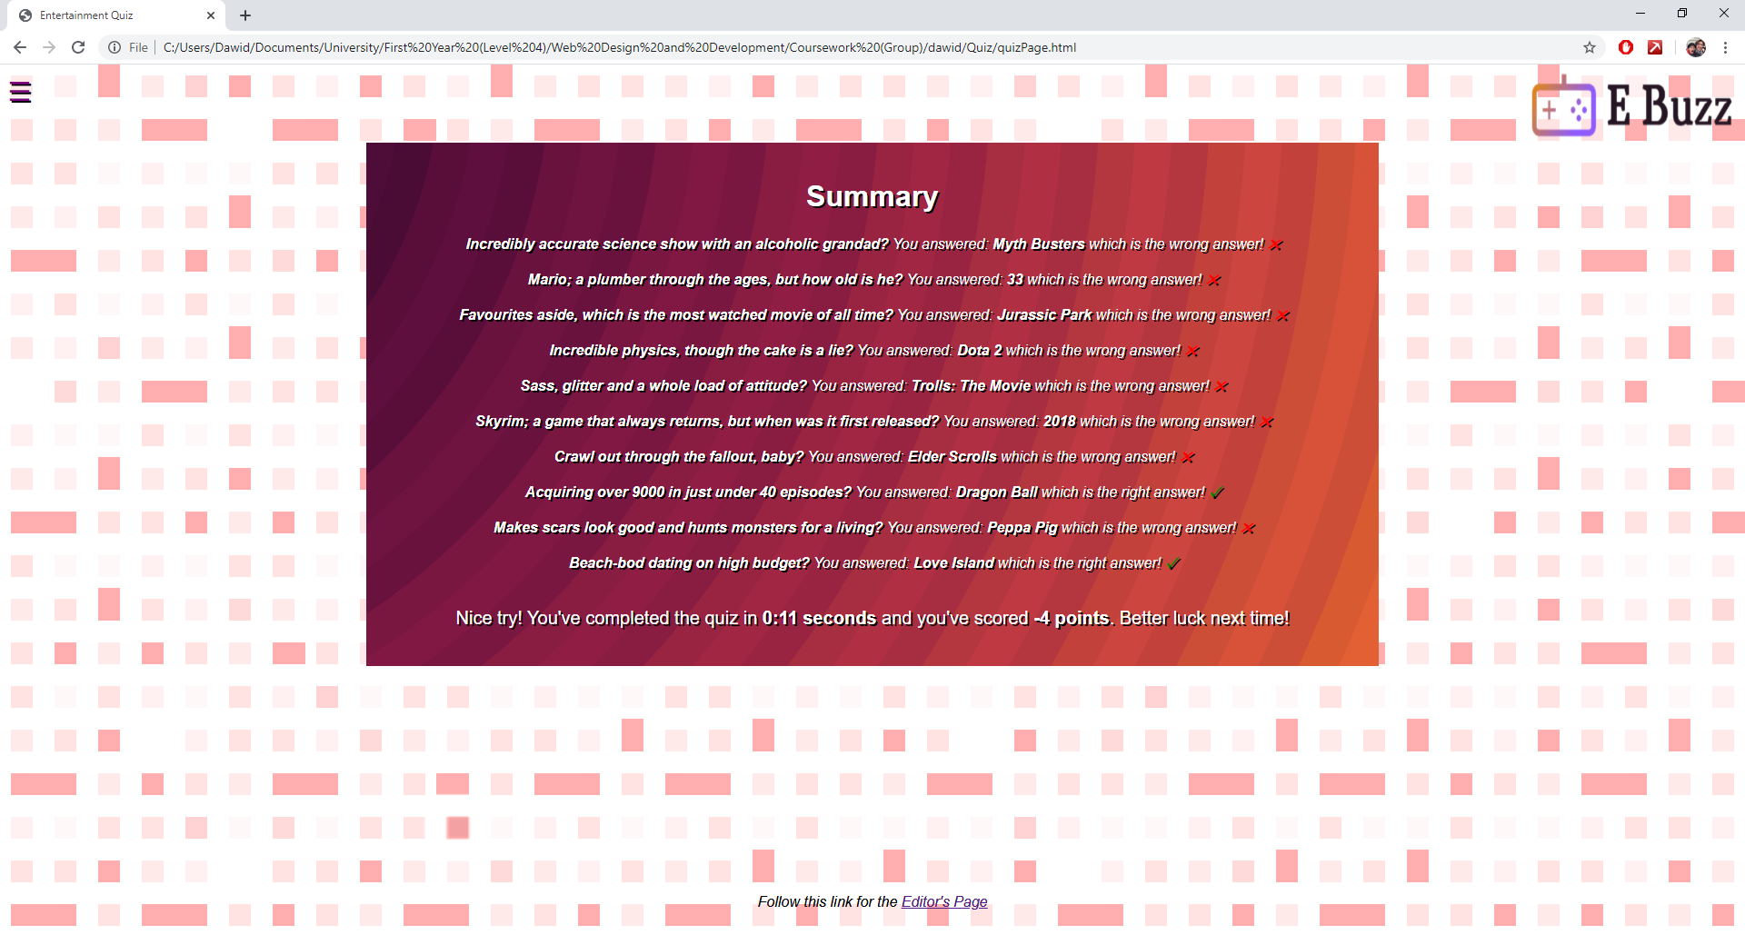

Filename: **studentProfilesPage.html**

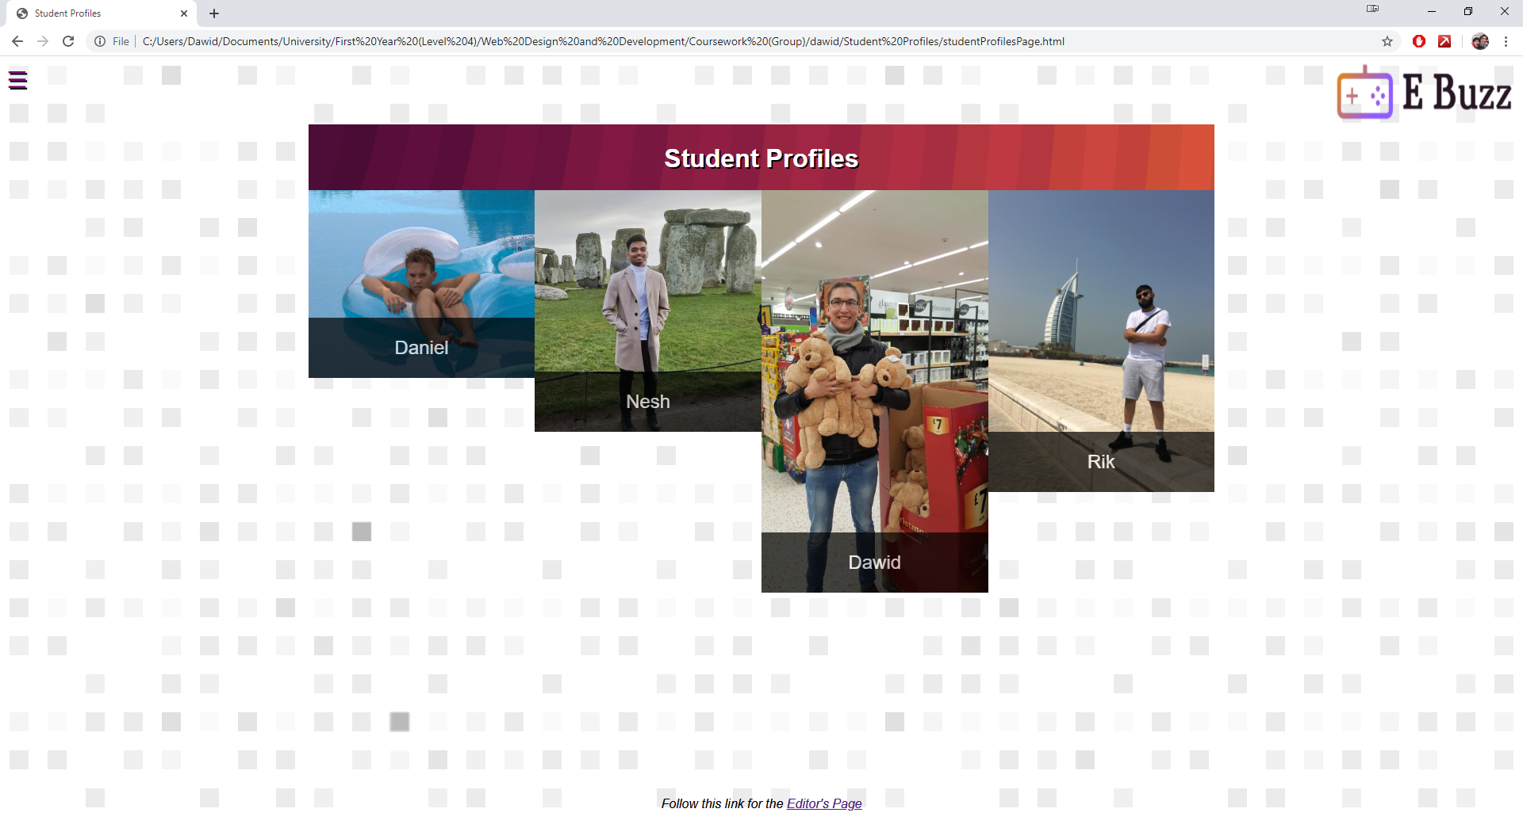

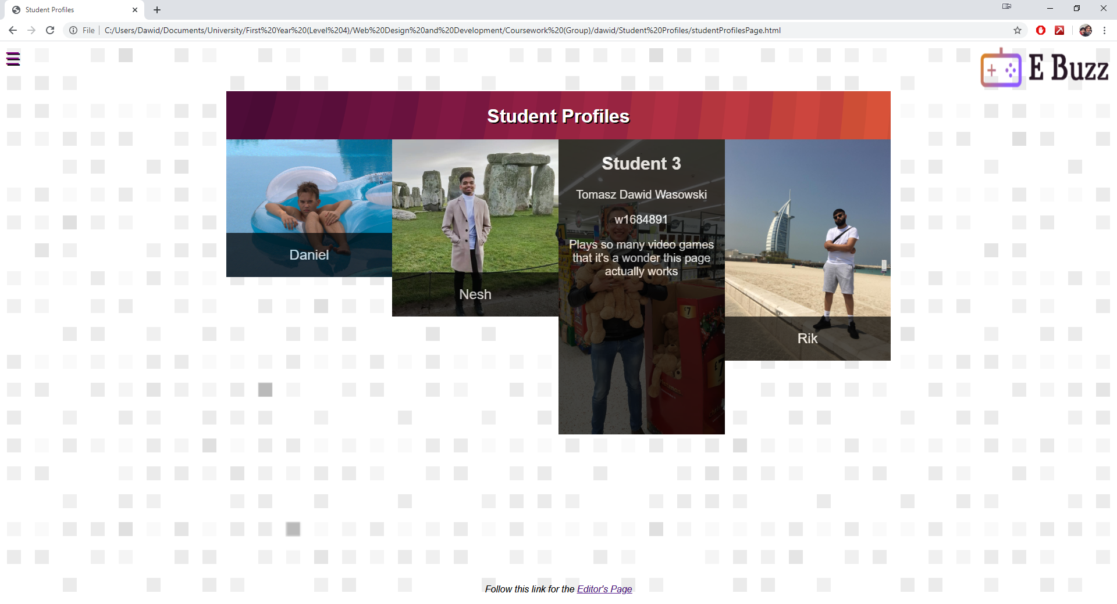

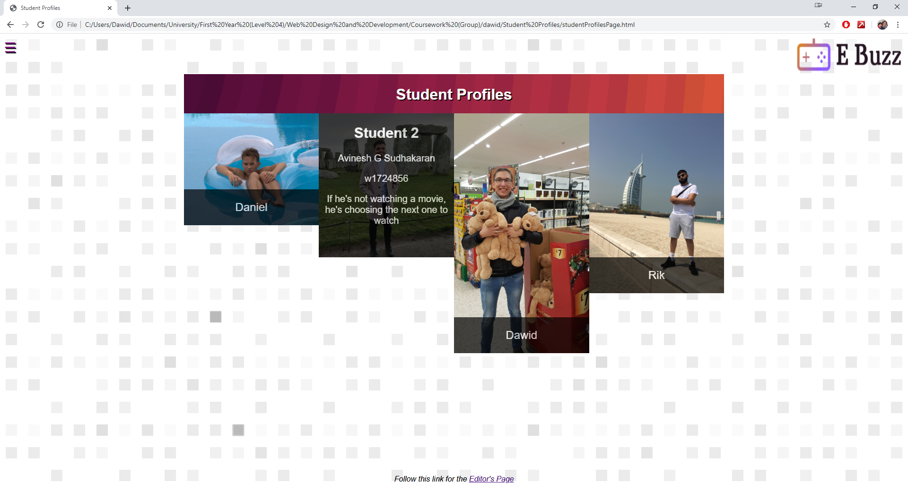

Filename: **additionalPage.html**

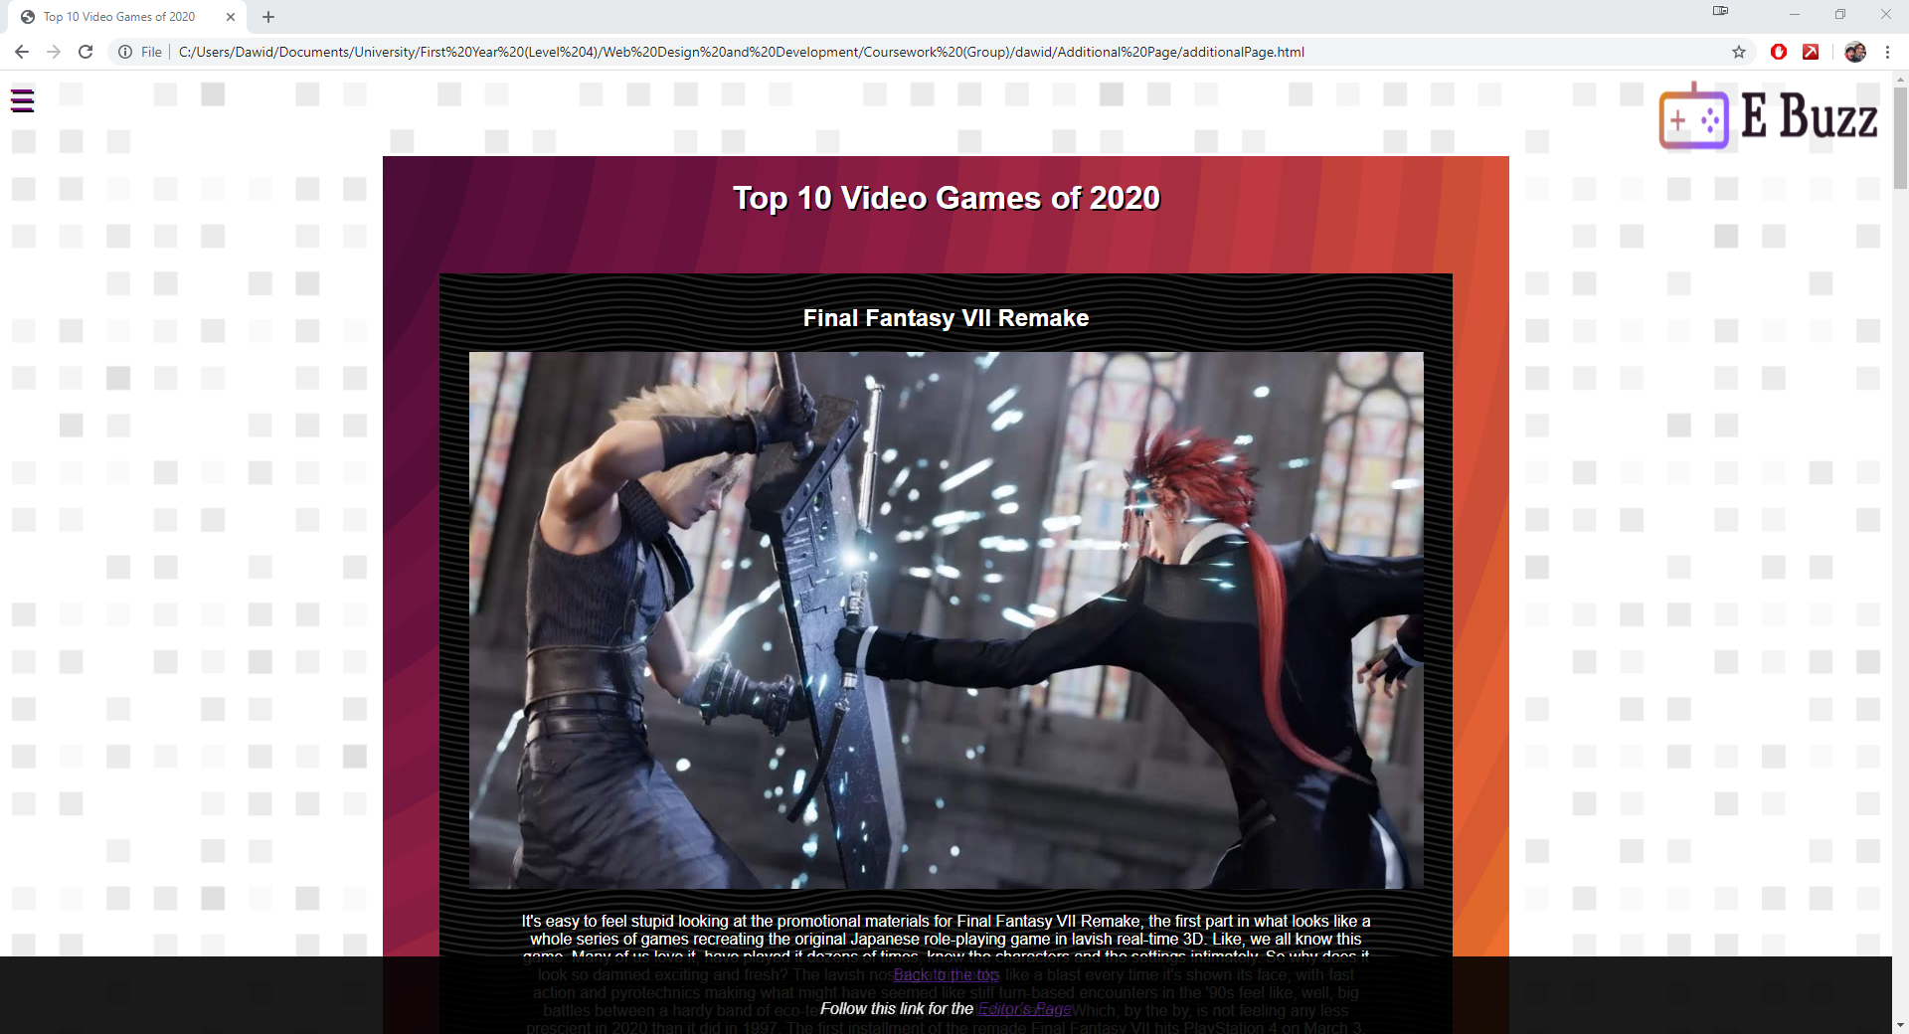

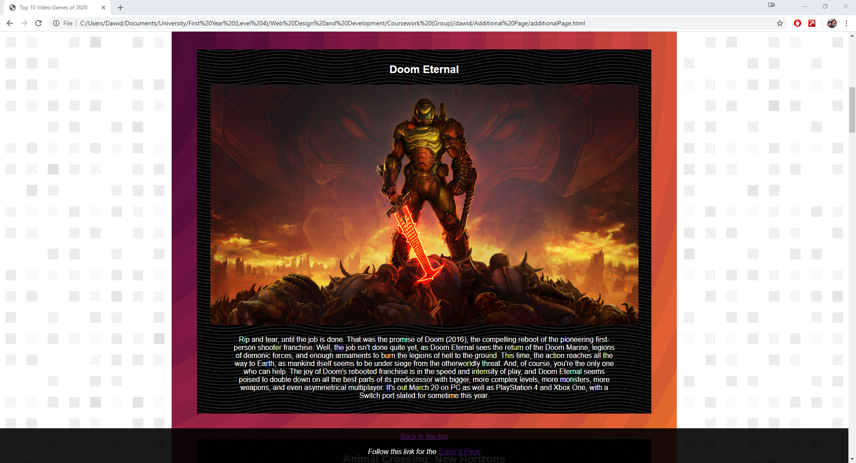

Filename: **editorPage.html**

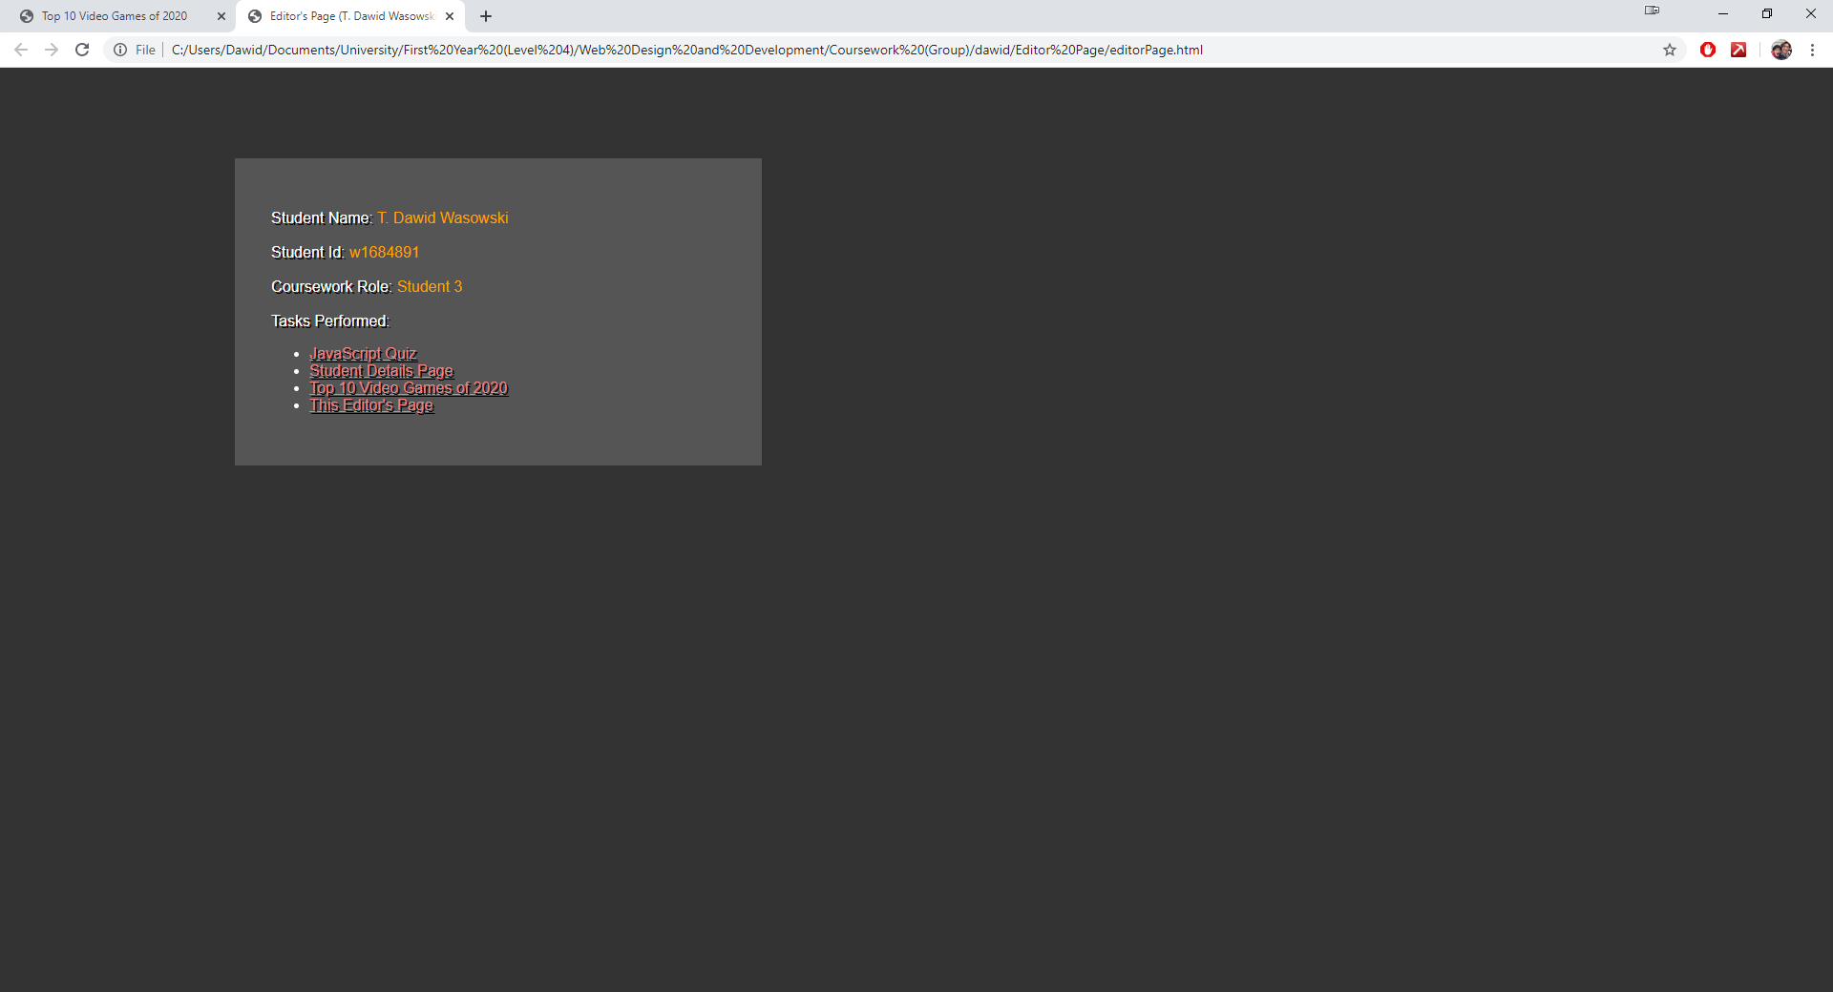

## Appendix C: Individual Statement

|  |  |  |  |
| --- | --- | --- | --- |
| Student Name: | **Tomasz Dawid Wasowski** | Student Id: | **w1684891** |
| State what tasks you carried out in the project. | | | |
| I’ve carried out the creation of the JavaScript quiz. It is time limited and produces an answer summary for the user. The summary includes the score, the time taken and includes a background colour change which is calculated using the user’s score.  I’ve created the student profiles page, with rollover images that include detail about the student, such as their full name, id and role in the group.  I’ve created an additional page for our website about the top 10 upcoming games of 2020. This page was a filler and just included some miscellaneous content that I’ve styled.  I also created an editor’s page with all my details and a summary of the work I’ve done. There is a link to this page from every page I’ve created, and every page can be accessed from the editor’s page.  I’ve ensured that my pages are consistent with the main page and navigation by linking to student 2’s external css and implementing their navigation menu.  I’ve used anchors throughout my pages to link to other pages. In addition, I’ve created an anchor on the additional page which links back to the top of the page.  Each page I’ve created has the page logo and links directly to my editor’s page through the link in the footer.  I’ve added additional JavaScript interactivity to the JS quiz, by implementing direct answer feedback to the user. This highlights the answers red if incorrect and green if correct directly upon the user’s click.  I’ve also taken a role as a team organizer of sorts for this project, creating our WhatsApp group and taking initiative on organizing meetups and booking library rooms for us to work in. | | | |
| State what you enjoyed and did not enjoy about teamwork. | | | |
| I enjoyed the communication and feedback that we had with each other. The fact that we could ask on WhatsApp for help, or for feedback on a task we were working on. I loved sharing implementation methods and bouncing ideas between each other.  I didn’t enjoy how individual our tasks were, making it very difficult merge them at the end. It was also difficult to get everyone together for calls and coursework meetings once the coronavirus crisis broke out. One member returned to their home country and didn’t have the resources to collaborate with us. Putting all our work together in the end was overall a bit of a struggle. | | | |
| State what you learnt about teamwork. | | | |
| I’ve learnt the importance of proper organization, communication and adequate preparation. I feel that if we came up with a better plan from the beginning, made a proper page template and decided who’s work influences who’s, it would have generally been a better experience for us.  I also feel like planning out and structuring meetings before they happened would’ve been significant. We met up quite a few times, but those meetings weren’t the most productive or fruitful overall. | | | |
| State what skills you gained/learnt from undertaking the project. | | | |
| I feel as though time management was a big skill I got to work on during this project. The skill of communicating / collaborating with others, and general teamwork.  Specifically, with my task, I think that problem solving was at the core. Especially when taking into consideration the quiz. It took a lot of iterative development to create it in the way I envisioned, and there were a lot of unexpected challenges I had to overcome on the way. | | | |
| State any strengths about yourself that emerged whilst undertaking the project. | | | |
| I think this was one of my weaker projects throughout this academic year, but if I was to pick a strength that emerged, it would have to be the problem solving. Being able to overcome some issues, such as mixing event handlers with loops and function calls while passing local parameters. Using the 2d array with a pointer to generate the questions is another thing I am quite happy with. | | | |
| State any weaknesses about yourself that emerged whilst undertaking the project. | | | |
| I think a clear weakness in this challenge was communication and teamwork. Because of the individual nature of my task (quiz and student profiles) I fully focused on those and didn’t step back to consider the entire website as a whole.  Keeping in closer touch with my teammates and communicating our ideas about the overall look and feel of the website would have been a much more successful approach. | | | |
| State how you would do things better if you were to undertake the project again. | | | |
| As mentioned above, I would have sat my team down and created a detailed plan/order of tasks. I would ensure that a template page is created and that everyone knows what is expected of them and how we’re putting it together before we even start working on our individual tasks.  I would focus my task to be a little more about the website as a whole, rather than a stand-alone package. That said, technically I don’t think I would change anything about the quiz or the student profiles page, as I like the way that both of those turned out.  I would put a little more work towards creating my own, uniquely styled additional page and include a navigation bar and a bread-crumb trail. | | | |
| Additional general or project specific comments: | | | |
| Firstly, I would like to apologize for going slightly above the max word limit on each of the sections! I felt as though there was so much to talk about.  As for the project, speaking from the perspective of the JS focused student 3, I would love to have been able to do a little more CSS styling that would actually award me marks.  I couldn’t justify spending too much time on my additional page without any additional marks, but I felt as though the report part of the coursework was very much focused on the UX and UI design and styling.  Having worked primarily on the JavaScript technical side of the quiz, I feel as though I didn’t quite have the opportunity to explore all the UX and UI styling when it came to things like navigations menus, headers and footers and general content. There was not much to do with forms either.  Overall, I am happy with the project, the result and the support/feedback we were given along the way. I feel like the UoW staff put a lot of effort to guide us through this coursework and I am very grateful for that. | | | |
| Student Signature: | **T. Dawid Wasowski** | Date: | **23/03/20** |